Faraday

Army Project Plan

Implementation is the Name of the Game

James Phillips

March 2016

Introduction 3

Project Initiation 4

Project Monitoring 5

Monitoring Points 5

Milestones 5

Critical Paths 5

Risks and Mitigation 6

Financial Risks 6

Logistics Risks 6

Conclusion 7

Bibliography and Sources 8

Appendix A – Meeting Logs 9

Appendix B – Monitoring Log 10

Appendix C – Booking Design 11

Appendix D – Questionnaire 12

Appendix E – Workshop Timetable 13

Appendix F – Purchase Requisition Form 14

Appendix G – Initial Logistics and Finance Project Plan 15

Appendix H – Revised Logistics and Finance Project Plan 16

Appendix I – Witness Statement 17

# Introduction

The Faraday company have been asked by the British Army’s Royal Signal Corps to design and produce a scale model of a trailer manoeuvring system that in full size usage will be able to move a trailer usually towed behind a Land Rover. The model should be functional and be able to move a scale weight equivalent to that which will be required of the final full size product.

This document describes the activities of the Logistics & Finance team in planning, monitoring and reviewing progress to assist the whole Faraday company in achieving the project objective.

In this document I describe how the section of the project we handled (Logistics & Finance) handled the sub-plan and the activities we undertook. These include:

* Project Initiation
* Project/Progress Monitoring
* Risks and Mitigation

Finally, I summarise how successful we have been and reflect on actions, which could have been done differently to improve performance in the project.

# 

# Project Initiation

The project was announced on 8th January, and the initial roles for the sub-team leaders/managers were agreed on 20th January. At this session we understood more of the requirements and made initial plans for the design. From this point it was possible to assign roles in the sub-teams as we have a project scope and were able to identify the work streams.

The work streams were identified as:

* Logistics & Finance – looking after the ordering, budget and some documentation
* Marketing – responsible for the product documentation and video for presentation
* Design & Build – this is the engineering team, responsible for the construction
* Systems Control – this is the programming team, responsible for coding the control sub-system.

An overall project plan could be created early in the project to provide a guide as to how the project could progress. Each sub-team could then produce plans for the detailed elements that needed to be addressed by that team. As the Manager for Logistics & Finance I prepared a plan for the activities in this work stream.

The initial project plan for the project as a whole and the initial Logistics & Finance plan are shown in Appendix G.

# Project Monitoring

We used the monitoring points and milestones on the Logistics & Finance plan to check that we were making the required progress. At each meeting we checked where progress should be, where we were and assigned any extra or corrective actions. Notes on the meetings are in Appendix A – Meeting Notes.

The critical path for the overall project was dependent on the Logistics & Finance team getting the items ordered and with the engineering teams (Design & Build and Systems Control) in time to produce the trailer and the control system.

## Monitoring Points

For Logistics & Finance the monitoring points we setup were to ensure that there was progress in each of our sub-goals:

Understand Overall Project

Understand Requirements

Understand Design of the Product

Collate Required Parts for the Design

Gather Information for Workshop

Gather Information for Questionnaire

Gather Information for Booking system

Checking on the Budget

Ordering Parts

Receiving Parts

Distribution of Parts to Design & Build team

Write-up of the Workshops

These are visible on the plan in Appendix H - Revised Logistics & Finance Project Plan.

Each monitoring point was recorded in the Monitoring Log as we progressed – so this could be checked back against the plan. This allowed myself as the Logistics & Finance Manager to report progress to the Programme Manager and the heads of the other sub-teams. A copy of the Monitoring Log is in Appendix B – Monitoring Log.

## Milestones

There are also several milestones that have been laid out along the course of the project. Deciding on the final design, placing the order for materials and gathering them once they arrive, beginning construction and assembling the final product and finally the presentation to the Army all featured on our plan.

In Appendix H - Revised Logistics & Finance Project Plan, the project plan Milestones are indicated with a diamond symbol.

## Critical Paths

Whilst the overall project has a critical path, the Logistics & Finance plan also has a critical path, which we needed to ensure was not conflicting with the overall plan. Knowing when our milestones were due and being able to change some elements without disrupting the whole project meant observing the critical path.

In Appendix H - Revised Logistics & Finance Project Plan, the critical path of the project has been coloured red by the project-planning tool.

# 

# Risks and Mitigation

## Financial Risks

The project has a defined budget, the items required to complete the build need to be identified and the best prices found. There is a risk that the design phase fails to identify an item that is required and this is not then affordable later in the project.

When we started, it was decided that the financial plan should aim to deliver the project at around 75% of the budget, allowing for unexpected expenditure to occur in order to mitigate the risk.

In reality the parts requirements ended up utilising almost the entire budget. This would have caused a problem if the Design & Build or Systems Control teams had required additional parts (we have approx. £6.00 remaining in the budget).

A copy of the budgeted items is featured in Appendix F – Purchase Requisition Form.

## Logistics Risks

Making sure that plenty of resources are available for use by all teams is a way of avoiding the risk of running out of supplies and being unable to complete work. This meant that Faraday needed to produce a parts list early in the project allowing for all components to be sourced at the best prices and allowing for delivery lead times.

The project plan for production included the delivery of goods – allowing easy identification of problems caused by delays in logistics, this will mitigate the effect of the delay.

# Communications

Four types of communication were required in the project:

* Communication with the sub-team (Logistics & Finance)
* Communication with the Team (Faraday) Programme Manager and other leads
* Communication with the customer on requirements
* Communication re: Purchasing

Within the Logistics & Finance team, we concentrated on working on the items assigned to us, which were:

* Collect orders, check budget and procure items
* Produce a Workshop Timetable
* Produce a Questionnaire for evaluation of the product
* Produce an initial User Interface design for the booking page

The evidence that these items were produced is in the appendices C,D,E and F of this report.

To communicate progress within the team was easy – we held a meeting at the start of the session to check on what was needed, then confirmed next steps at the end of the session. These were documented in meeting notes (Appendix A – Meeting Logs has records of these).

Communication with the Programme Manager and other leads was achieved by meeting face-to-face and reporting on the progress we were making. The decisions were recorded in a meeting note; an improvement to the process would have been to share this with the Programme Manager and other leads.

We needed to have communication with the client to determine the format that the Workshop programme would be. I did this face-to-face, after which a prototype was agreed in the session. If this had taken longer to produce I would have sent an email to confirm the design was acceptable, including the mock-up.

Communication re: Purchasing was achieved by emailing the Business Manager (Mike Halliday), who then arranged for the actual purchases to be made.

# Conclusion

This document introduced the project in which the Faraday company have been asked by the British Army’s Royal Signal Corps to design and produce a scale model of a trailer manoeuvring system that in full size usage will be able to move a trailer usually towed behind a Land Rover. The model should be functional and be able to move a scale weight equivalent to that which will be required of the final full size product.

This document has described the activities of the Logistics & Finance team in planning, monitoring and reviewing progress to assist the whole Faraday company in achieving the project objective. The report covered the topics:

* Project Initiation
* Project/Progress Monitoring
* Risks and Mitigation

Evidence of the work on these items has been referenced and is included in the Appendices to the report.

The Logistics & Finance team have delivered on the planned activities, handling some changes and challenges as the project progressed. The team have successfully taken and processed orders to get the project’s build and systems teams working on the actual prototype. The team have also produced the other materials required.

To improve on the performance of the team, I would in a future project circulate notes from each meeting quickly after the meeting to ensure everyone has the same set of actions. I would also engage with the external stakeholder earlier on the design requirements when needed.

The equipment required was procured and delivered to the Design & Build and Systems Control teams on time, but we came close the using the whole budget on the early purchases. This left no contingency funds for items we may have needed but not recognised early in the project. In future projects, I would communicate this more clearly when arranging with the other project participants the ordering / budgeting process.

# Bibliography and Sources

|  |  |
| --- | --- |
| Source | Information |
| BTEC Level 3 Information Technology Book 1 - Anderson, Jarvis, Kaye, Lawson, McGill, Phillips, Smith | Background Info |
| <http://www.projectlibre.org/> | ProjectLibre software used to create project plan. |

# Appendix A – Meeting Logs

|  |  |
| --- | --- |
| Team | Logistics and Finance |
| Date | 20th January 2016 |
| Attendees | James Phillips Robert Tyler  Alistair Lunn Harrison Spence  Julian Kessler-Wentworth Luke Ledgard  Andrew Flint Tom Widdis  Rebekah Kitchin Ryan Krage |
| Notes | We understand the tasks required of the Logistics and Finance team are:   * Collect orders, check budget and procure items * Produce a Workshop Timetable * Produce a Questionnaire for evaluation of the product * Produce an initial User Interface design for the booking page   Agreed roles within the team  Collect orders and arrange purchasing  James Phillips (Manager)  User Interface Design for Booking  Robert Tyler  Alistair Lunn  Harrison Spence  Ryan Krage  Questionnaire  Julian Kessler-Wentworth  Luke Ledgard  Andrew Flint  Workshop Timetable  Tom Widdis  Rebekah Kitchin |
|  |  |

|  |  |
| --- | --- |
| Team | Logistics and Finance |
| Date | 26th January 2016 |
| Attendees | James Phillips Robert Tyler  Alistair Lunn Harrison Spence  Julian Kessler-Wentworth Luke Ledgard  Andrew Flint Tom Widdis  Rebekah Kitchin Ryan Krage |
| Notes | We understand the design that the other teams are going to work to, we know our tasks and are monitoring progress.  Collect orders and arrange purchasing  Waiting for the design and technical teams to provide parts requirements. Need to get any details of marketing orders.  User Interface Design for Booking  Are able to start design of the booking page.  Questionnaire  Are ready to start working on questions that can be asked following the presentation – evaluation questionnaire  Workshop Timetable  Starting work on what the timetable will look like (format and content).  Issues: No problems with progress thus far, nothing to raise as a concern with the Programme Manager. |

|  |  |
| --- | --- |
| Team | Logistics and Finance |
| Date | 1st February 2016 |
| Attendees | Tom Helyer Programme Manager  James Phillips Logistics & Finance  Joe Bond Systems Control  Adam Taylor Design & Build  Becky Morris Marketing |
| Notes | Discussed overall progress  Took requirements for parts from Joe and Adam on behalf of Systems Control and Design & Build Teams.  No requirement from Becky on behalf of Marketing for any parts/supplies. |

|  |  |
| --- | --- |
| Team | Logistics and Finance |
| Date | 1st February 2016 |
| Attendees | James Phillips Robert Tyler  Alistair Lunn Harrison Spence  Julian Kessler-Wentworth Luke Ledgard  Andrew Flint Tom Widdis  Rebekah Kitchin Ryan Krage |
| Notes | We understand the design that the other teams are going to work to, we know our tasks and are monitoring progress.  Collect orders and arrange purchasing  Have the orders from Design & Build and Systems Control. These are being entered to the Purchase Order form.  Marketing have no purchase items.  User Interface Design for Booking  Booking page design underway but slow, need to revise expected completion date.  Questionnaire  Have a list of questions to consider putting into a format  Workshop Timetable  Have example content, need to discuss the layout with the client and have queries on what should be in the session.  Had a discussion with customer (Matt) on the Workshop content (James Phillips and Tom Helyer) to get answers to queries.  Issues: No issues, slower progress on booking design than we hoped, change of planned date. Budget concern on order value. |

|  |  |
| --- | --- |
| Team | Logistics and Finance |
| Date | 4th March 2016 |
| Attendees | Tom Helyer Programme Manager  James Phillips Logistics & Finance  Joe Bond Systems Control  Adam Taylor Design & Build  Becky Morris Marketing |
| Notes | Discussed overall progress  Collected the parts ordered and distributed to teams.  Checked all parts were as expected/required. No issues. |

|  |  |
| --- | --- |
| Team | Logistics and Finance |
| Date | 4th March 2016 |
| Attendees | James Phillips Robert Tyler  Alistair Lunn Harrison Spence  Julian Kessler-Wentworth Luke Ledgard  Andrew Flint Tom Widdis  Rebekah Kitchin Ryan Krage |
| Notes | Collect orders and arrange purchasing  Items arrived and collected, distributed to the Design & Build and Systems Control Teams (with the other leads).  User Interface Design for Booking  Booking page design near completion.  Questionnaire  Have a list of questions and are putting into a format.  Workshop Timetable  Are working to the format agreed with the customer (Matt)  Issues: No issues. |

|  |  |
| --- | --- |
| Team | Logistics and Finance |
| Date | 17th March 2016 |
| Attendees | James Phillips Robert Tyler  Alistair Lunn Harrison Spence  Julian Kessler-Wentworth Luke Ledgard  Andrew Flint Tom Widdis  Rebekah Kitchin Ryan Krage |
| Notes | We worked out that we had completed our tasks. End of session review:  Collect orders and arrange purchasing  Completed  User Interface Design for Booking  Completed  Questionnaire  Completed  Workshop Timetable  Completed  Issues: No issues. |

# Appendix B – Monitoring Log

|  |  |  |  |
| --- | --- | --- | --- |
| Date | Activity | Status | Notes |
| 20/1 | Understand Overall Project | Ok |  |
| 20/1 | Understand Requirements | Ok |  |
| 26/1 | Understand Design of the Product | OK |  |
| 26/1 | Gather Information for Workshop | Queries |  |
| 26/1 | Gather Information for Questionnaire | Ok |  |
| 26/1 | Gather Information for Booking system | Ok |  |
| 1/2 | Collate Required Parts for the Design | Ok | Budget concern |
| 1/2 | Gather Information for Workshop | Ok | Queries answered |
| 1/2 | Gather Information for Questionnaire | Ok |  |
| 1/2 | Gather Information for Booking system | Flagged | Slow progress |
| 1/2 | Checking on the Budget | Flagged | No contingency |
| 1/2 | Ordering Parts | Ok | Completed |
| 4/3 | Receiving Parts | Ok | Completed |
| 4/3 | Distribution of Parts to Design & Build team | Ok | Completed |
| 4/3 | Write-up of the Workshops | Ok | Completed |
| 4/3 | Design of Booking | Ok | Completed |
| 4/3 | Questionnaire Questions / Format | Ok | Completed |
| 17/3 | Workshop Timetable complete | Ok |  |
| 17/3 | Booking Design Complete | Ok |  |
| 17/3 | Questionnaire Complete | Ok |  |
| 17/3 | Completion of all actions. | Ok | Reported to PM (Tom Helyer) |

# Appendix C – Booking Design

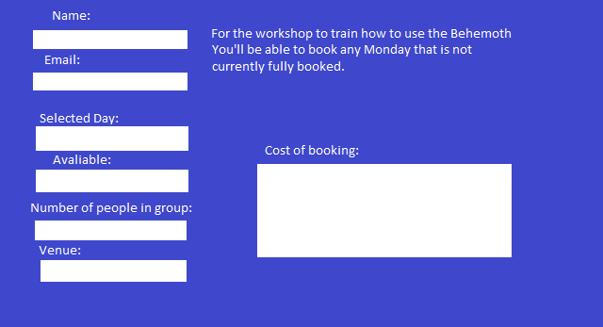

# Appendix D – Questionnaire

**1. How would you rate the quality of the product?**

Very high quality

High quality

Neither high nor low quality

Low quality

Very low quality

**2. How well do you think our product meets the requirements?**

Extremely well

Very well

Somewhat well

Not so well

Not at all well

**3. How would you rate the value for money of the product?**

Excellent

Above average

Average

Below average

Poor

**4. Compared to other solutions, is our product quality better, worse, or about the same?**

Much better

Somewhat better

About the same

Somewhat worse

Much worse

**5. What is your age?**

 14 to 18

19 to 24

25 to 34

35 to 44

45 to 54

55 to 64

65 to 74

75 or older

**6. How well did the training answer your questions or solve your problems with the product?**

Extremely well

Very well

Moderately well

Slightly well

Not at all well

**7. Overall, are you satisfied with the employees at our company, neither satisfied nor dissatisfied with them, or dissatisfied with them?**

Extremely satisfied

Moderately satisfied

Slightly satisfied

Neither satisfied nor dissatisfied

Slightly dissatisfied

Moderately dissatisfied

Extremely dissatisfied

**8. How convenient is our product to use?**

Extremely convenient

Very convenient

Moderately convenient

Slightly convenient

Not at all convenient

**9. How professional is our company?**

Extremely professional

Very professional

Somewhat professional

Not so professional

Not at all professional

**10. Do you have any other comments, questions, or concerns?**

# Appendix E – Workshop Timetable

|  |  |  |
| --- | --- | --- |
|  | Event | Description |
| 08:30 – 08:40 | Introduction | Introduction to the trailer positioning system, and meet the mentors. |
| 08:40 – 08:50 | Health and Safety | In this interval we will go over the health and safety regarding the system. |
| 08:50 – 09:10 | Setting up the device | You will be shown how to safely and efficiently set up the system. |
| 09:10 – 09:40 | Operation of the device | You will be shown in depth how to operate the system safely. |
| 09:40 – 09:50 | Maintenance and upkeep | You will spend this time learning how to maintain the system safely and keep it in working order. |
| 09:50 – 10:25 | Application of knowledge | You will be taken into the field environment and be asked to demonstrate your knowledge on using the device on a real trailer. |
| 10:25 – 10:30 | Question time | Time to ask any questions relevant to the course and system. |
| 10:30 – 13:30 |  |  |
| 13:30 – 13:40 | Introduction | Introduction to the trailer positioning system, and meet the mentors. |
| 13:40 – 13:50 | Health and Safety | In this interval we will go over the health and safety regarding the system. |
| 13:50 – 14:10 | Setting up the device | You will be shown how to safely and efficiently set up the system. |
| 14:10 – 14:40 | Operation of the device | You will be shown in depth how to operate the system safely. |
| 14:40 – 14:50 | Maintenance and upkeep | You will spend this time learning how to maintain the system safely and keep it in working order. |
| 14:50 – 14:25 | Application of knowledge | You will be taken into the field environment and be asked to demonstrate your knowledge on using the device on a real trailer. |
| 14:25 – 14:30 | Question time | Time to ask any questions relevant to the course and system. |

# 

# Appendix F – Purchase Requisition Form

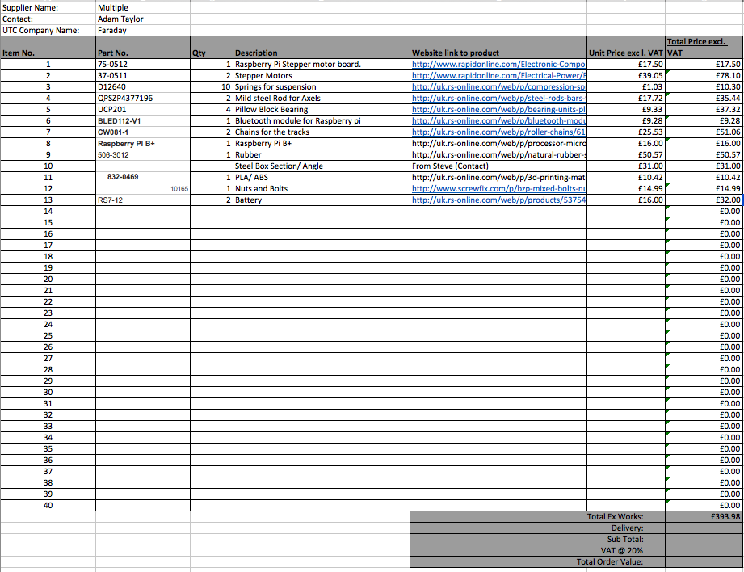

# Appendix G – Initial Project Plan

# Appendix H – Revised Logistics and Finance Project Plan

# Appendix I – Witness Statement